# TiC (Transparency in Coverage) - Cost Estimator Tool

Important Information

TiC – Cost Estimator Tool Process

TiC Letter Failed Pop-Up

Member Received Letter and Doesn’t Know Why

Viewing TiC Letter History

Sample TiC Letter

Related Documents

**Description:** Outlines the process to submit a request to print and mail the Drug Cost Comparison member letter (TiC Letter).

|  |
| --- |
| Important Information |

Upon request, the Federal Government requires PBMs to send members a written document to help them understand how the costs for covered health care items and services are determined by their plan.

Please attempt to answer all drug cost comparison questions the member may have while you are helping them on the call.

* Do not proactively offer to send TiC/Drug Cost Comparison letters to the member.
* Only order a TiC/Drug Cost Comparison letter for a member if they have specifically requested a physical letter of the information to be mailed to them.

If a member inquires why they received a letter, refer to Member Received Letter and Doesn't Know Why section below.

Top of the Document

|  |
| --- |
| TiC – Cost Estimator Tool Process |

After a test claim has been run, and pricing for COVERED drugs has been returned for the test claim both Mail and POS, a new button will display to be used to trigger a TiC Letter request for POS.

* To get one for Mail and POS, run the test claims separately.

 The button will remain disabled for test claims that are priced but NOT COVERED.

** Only order a TiC/Drug Cost Comparison letter for a member if they have specifically requested a physical letter of the information to be mailed to them.**

** Do not use this functionality for Test Accounts for clients prior to going live or during open enrollment (Universal IDs or other accounts listed as Test Accounts).**

**Turnaround Time:** TiC letter(s) should be sent within 2 business days.

If a member requests a written estimate of their prescription drug plan coverage and/or cost sharing for a medication (TiC Letter), follow the steps below:

|  |  |
| --- | --- |
| **Step** | **Action** |
| **1** | Submit a Test claim.  **Notes:**   * Select correct eligible member from drop down menu. * Cost Comparison letters can be generated for only 1 medication for a specified day supply and quantity. When a test claimis submitted for **both MAIL and RETAIL**, the Submit Tic Letter indicator will display and Retail will receive the print service (the Cost Comparison letter will only be sent for Retail). A pop-up message will display “Reminder: Only Mail or Retail test claim should be submitted individually to generate TiC letter.” * If a Mail Cost Comparison letter is needed, cancel and resubmit an individual Test Claim for MAIL only. |
| **2** | a. Click **Submit** (under Drug Cost Comp Tic Letter header).  **Result:** A confirmation popup will display, “Are you sure you want to submit Tic Letter?” Followed by the members mailing address on file.    b. Verify address, if incorrect, refer to the appropriate work instruction.  **Note:** If mailing address is not available, a pop will display, “Address not available on User Account and is required.” Refer to the appropriate work instruction if the address needs to be changed.    c. Click **Ok**.  **Note:**   * One letter request is sent per medication. You have to click Submit for each medication listed that member requests a letter for. * If Cancel is selected, the information will NOT be submitted to print service and the popup will close.   The button will remain disabled for test claims that are priced but NOT COVERED (the Submit button will not be highlighted). |
| **3** | Inform the member:  Please note that the medication information you’ve requested will be included in the letter that will be sent, and it may be sensitive in nature. |
| **4** | Click **OK**.  Advise member the letter will be mailed within 2 (two) business days.  **Result:** The information will be submitted to print service and the popup will close. The following popup will display: “Tic Letter successfully sent to print service”.    **Note:** If print service request fails, a popup will display “TiC Letter failed sent to print service.” |

Top of the Document

|  |
| --- |
| TiC Fail Pop-Up |

Complete the steps below if a TiC Fail pop-up is received:

|  |  |  |
| --- | --- | --- |
| **Step** | **Action** | |
| **1** | 1. Review test claim. 2. Ensure correct NPI/NCPDP is entered correctly for the pharmacy being used. Refer to appropriate Test Claim work instruction. | |
| **2** | Submit test claim again and try to submit for TiC Letter. | |
| **If...** | **Then...** |
| Success | Inform member it was successful and the letter will be mailed within 2 (two) business days. |
| Fail | Call Senior Team for assistance. |
| **3** | Follow Senior guidance. | |
| **If Senior teams states...** | **Then...** |
| Success | Inform member it was successful and the letter will be mailed within 2 (two) business days. |
| Fail | Frontline agent needs IT ticket submitted. |
| **4** | **Vendor Only Process:** Agent should refer to supervisor for a ticket to be created.  **All Other CCRs:**   1. Contact Supervisor who will advise of the appropriate non-working reason code. 2. **Contact IT at 1-855-280-4872 to submit an IT ticket**, requesting escalation to Tier 1 with the following:  * Information provided for ticket will include: * Select correct option: PeopleSafe * Member ID * Member Name * Drug NDC (Name and strength) * Quantity * Day Supply * Mail or POS * NPI/NCPDP used * Address the TiC Letter is being sent to * Date and Time of the Failed pop-up * Agent and supervisor name and email for resolution to be sent * **Provide the following addresses to the IT colleague to ensure a resolution is sent:** [tracy.vigil@cvshealth.com](mailto:tracy.vigil@cvshealth.com) and [elizabeth.kenny@cvshealth.com](mailto:elizabeth.kenny@cvshealth.com)   **Result:** Tracy and Elizabeth will process the TiC letter or call the member if the ticket is not resolved within 2 (two) business days.  **Note:** No further action is required once a ticket has been opened. You may receive an email when the ticket is completed. | |

Top of the Document

|  |
| --- |
| Member Received Letter and Doesn’t Know Why |

If a member inquires why they received a letter, follow the steps below to assist with determining letter origination:

|  |  |
| --- | --- |
| **Step** | **Action** |
| **1** | Go to Communication History Tab in PeopleSafe. |
| **2** | Click **View TiC Letters**.    **Result:** A new panel with TiC Letters that have been requested/printed within the past 3 months for that member will display.    **Note:** “No Records Found for Given Search Criteria” will display if no letter history can be found. |
| **3** | Click the appropriate hyperlink to view the TiC Letter.  **Note:** A pdf of the actual letter that was sent to member will display. |
| **4** | Review account activity to determine if the letter date reflects the same case or log activity date. You can inform that the letter was generated based off an interaction from XX date.   * If no account activity, inform the member that the letter was sent in error. |

Top of the Document

|  |
| --- |
| Viewing TiC Letter History |

Follow the steps below to view TiC Letters requested/printed for the member:

|  |  |
| --- | --- |
| **Step** | **Action** |
| **1** | Go to Communication History Tab in PeopleSafe. |
| **2** | Click **View TiC Letters**.    **Result:** A new panel with TiC Letters that have been requested/printed within the past 3 months for that member will display.    **Note:** “No Records Found for Given Search Criteria” will display if no letter history can be found. |
| **3** | Click the appropriate hyperlink to view the TiC Letter.  **Note:** A pdf of the actual letter that was sent to member will display. |

Top of the Document

|  |
| --- |
| Sample TiC Letter |

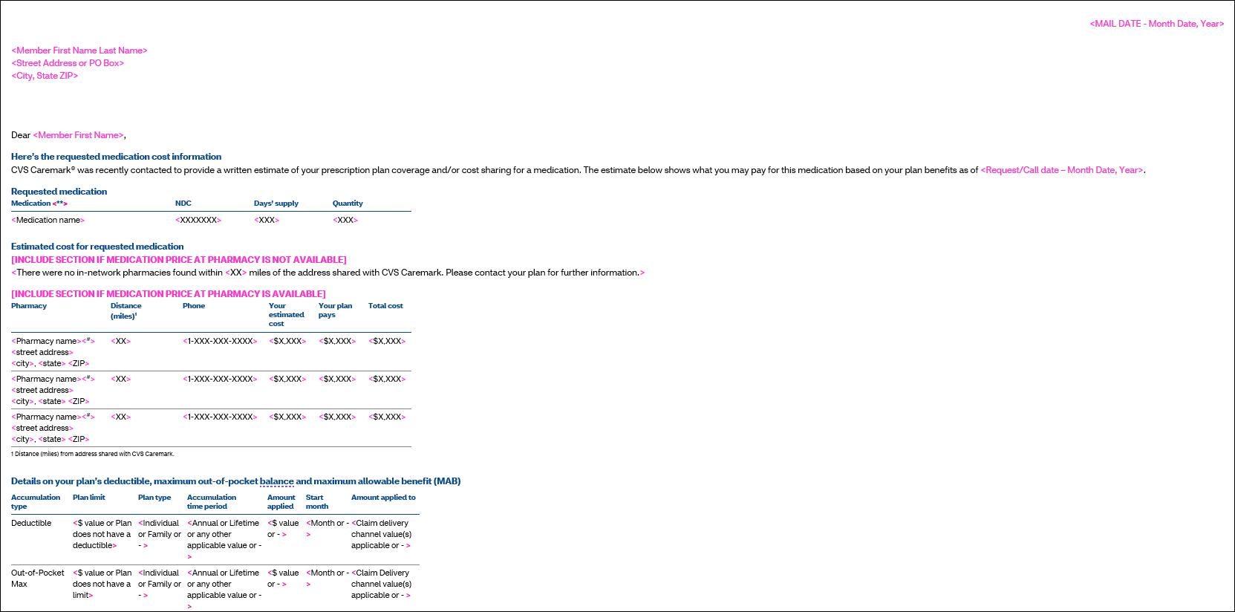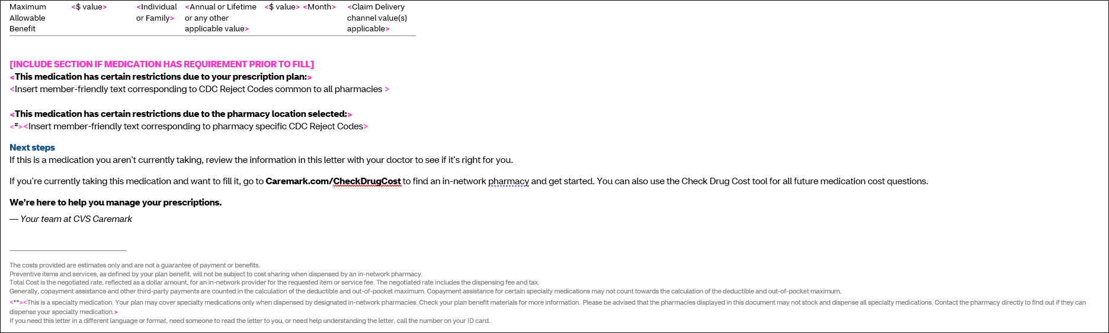

Top of the Document

|  |
| --- |
| Related Documents |

**Parent Document:** [CALL-0049 Customer Care Internal and External Call Handling](https://policy.corp.cvscaremark.com/pnp/faces/DocRenderer?documentId=CALL-0049)

**Abbreviations/Definitions:** Customer Care Abbreviations, Definitions, and Terms Index

Top of the Document

Not To Be Reproduced Or Disclosed to Others Without Prior Written Approval

**ELECTRONIC DATA = OFFICIAL VERSION / PAPER COPY = INFORMATIONAL ONLY**